Our journey together
Feedback from Forum on ideas for a Future Parish Pastoral Council

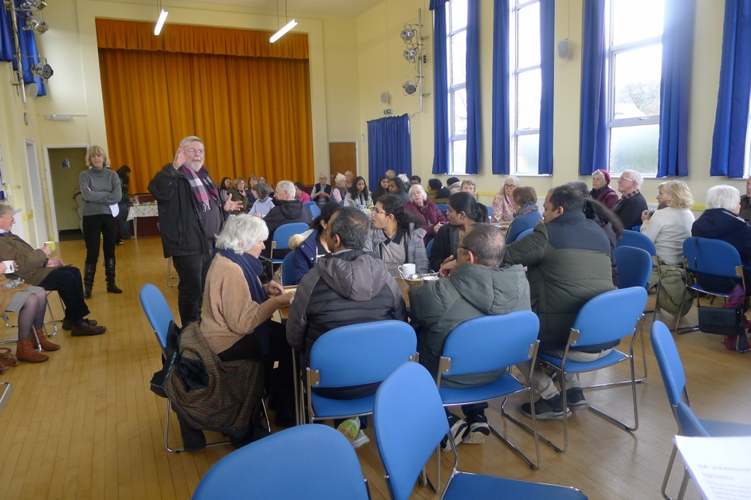

Last Sunday, over 60 parishioners (young and young-at-heart) joined the conversation around suggestions for how our parish might develop a new Parish Pastoral Council (PPC).
The suggested purpose of a new PPC is to discern God’s will for our parish. This was accepted by the majority. Many sought greater clarity on the purpose and the role of a PPC particularly on the relationship between a prayer-based focus and responding to the practical needs of the parish and wider community. Generally, people’s views focused on the finer details of the purpose of a PPC with many great ideas for how it could be formed, what it might do, and practical matters that a new Pastoral Council might need to consider as part of its role.
Clarity on what the PPC would be for was central for people to know what they might be called to do and whether to step forward. How to discern our own calling and understand whether God is calling us to serve on the PPC was trickier. People seemed to like the “Head, Hearts and Hands” model to help. Some thought opportunities for private and communal prayer would be helpful, with others preferring that someone else should ask them to serve.
There was no consensus about the suggested process for selection. The main concerns were the transparency of the proposed process, the authority of who decides, whether the parish would feel their views were represented and the relationship between a Pastoral Council with existing parish groups and the parish as a whole. Some liked the idea of a larger PPC – with flexible membership possible according to the changing needs of the parish.
The most frequent issue raised about whether they would consider serving on a new PPC (other than clarity of its purpose and what it was there to do) was knowing the time commitment, so we do not exclude people.
There were also some important other messages that emerged from the discussions, including how to meet the various needs of our younger parishioners, a call for greater ecumenism and needing to be a more welcoming parish.
A complete record of the points raised by the many small groups to 3 questions, is set out below.
The next steps will be for the working group to reflect on the responses and decide any changes to the suggested process towards and timing of forming a new pastoral council and whether the parish would like more time to consider its role and purpose.
Following this (which might involve another forum for us all beforehand) an invitation will be sent to all parishioners to consider what gifts they have and whether God is calling them to serve on a new Pastoral Council for our parish.

Yours in Christ,

Clare Simpson
Jane Palmer Elaine King
Michael Selby
Isabelle Wragg

- Suggested purpose of a new Pastoral Council: to discern God’s will for our parish.

- What does “discern” mean?
- Needs proper missionary vision.
- How is it to be put together and who?
- How will it be composed?
- Is there a successful model we can learn from [first]? – A model without a [resident] Parish priest in future?
- Collecting people’s views and thoughts – fresh ideas.
- How will it be accountable to the parish?
- Enabling /encouraging young people – meetings – supporting each other.
- Listening to the community.
- Promoting ecumenical links.
- Don’t know much about the last PPC.
- Come to find out more about a new PPC,
- Positively trying to find out what God wants me to do.
- To discern individual gifts of each parishioner, their unique expression and we have responsibility for each other’s uniqueness. = community (body of Christ )– group to inspires this.
- Time doing nothing and [just] listen to the Holy Spirit. It is a present to ourselves, each other – and the Holy Spirit - takes time.
- Prayer very important to know what each individual.
- I’d like to be more involved in the parish but feels very closed and cliquey. My old parish was very different.
- What I miss about the Knights of Columbus when we helped each other, looked after each other. [Enabling] a support system to help each other and into the community prayerfully.
- Have to make sure it’s the right thing.
- Welcoming is so important.
- Belonging to a group is very good as we hear each other’s views – we need each other.
- It’s all about love.
- It’s about belonging together in Christ.
- Coming here today not knowing is very good.
- Helping us to live Christ’s mission.
- Bringing people of the parish together.
- Enabling/encouraging us to do things together.
- Praying together with prayer meetings prepared
- Enabling more things for the children of the parish. – helping children understand, ….. group.
- Rephrased to read Helping us (ie parishioners) to discern God’s will for the parish so that we live God’s mission
- Bringing people of the parish together
- Organise activities
- Encouraging/enabling us to do things together
- Praying together with having prayer meetings – in particular,
- To meet once a month
- ‘Shape’ of the meeting:
  - Begin with the Rosary (5 decades)
  - Discussion based on a Bible Reading – helping us to come to know the Bible more (include Bible Quizzes)
  - Prayers of Intercession
- To provide more for the children – singing group; helping children understand (their faith)
- The PPC’s role should be to:
- support each other;
- welcome family members who are not Catholic (and/or consider improvements);
- be more proactive on the ecumenical front – more contact with other churches and participate in consultation with other churches;
- promote parish activities, including hall bookings with interest groups;
- to retain younger generations in their faith; post schools;
- to expand the ‘helper pool’ of those who perform necessary jobs in the parish, e.g. welcomers, readers, altar servers, teas and coffees, transport of communion;
- to encourage awareness about parish finances, e.g. legacies.
- [It should be]
- prayer-based;
- prayer and reflection in meetings;
- outward-focused;
- [have a clear] mission;
- pastoral in purpose;
- meet specific community need
- ecumenical.
- Fundamentally - it should be spiritually-led:
- Needs to have some practical areas;
- Better communication between the PPC and parish to avoid last PPC being seen as inconsequential;
- Not comfortable with the idea that the use of assets being decided entirely by PPC.
- Belief [faith?] can do radical things.
- Needs to be inclusive – a way to bring all voices together and use all the resources of the parish – of which there are many.
- [Don’t agree – decision making] no other body makes decisions, only recommends to the Priest or diocese.
- Don’t make people who don’t want to, join in – feel disenfranchised or marginalised.
- The PPC should – reach out to:
- the community; and
- other churches (needs more explanation of our beliefs & practices) out of date perception of Catholicism and Christianity in general); avoid “in-your-face” evangelisation. Lead by example. See how Christians love one another”.
- [clarity on relationship with] other bodies and organisations.
- Communicate, e.g. previous PPC was dissolved without discussion or notification to existing members of that.
- It can be confusing for young people with lots of different sources of authority (bible / parents / priest) so support through clearer education
- PPC could help young people by engaging more and pushing for things like Flame [CYMFED event in London]. Flame was brilliant, it would be great to have more events like it.
- PPC could seek to work out how to support young people when it is needed (and on issues as they arise). They could support through pray – particularly when stressed, e.g. exams
- agree [with the suggested purpose]
- What is God’s will? How do we all agree it is God’s will? Through prayer. and guidelines of the Catholic Church.
- [selection] Make sure everyone knows feedback – not personal, to allow for useful discussion and future growth of the parish.
- A PPC should
- have regular meetings;
- to be honest about what’s working well and what’s not working
- to assess the effectiveness of parish progress programmes and initiatives.

- What would help you understand if God is calling you to serve on a new Pastoral Council?
- A questionnaire (email to all), inviting us to consider if we are interested, asking what gifts we think we have and what we think might be useful to a PPC. Important to avoid the pitfall – some with great gifts may be too humble to offer themselves in service.
- Important to avoid only stepping forward if either the priest or someone else seemingly “important” has “asked you.” Must come from within.
- Knowing that as the issues facing the parish change over time, various parishioners may be invited to step in with their gifts – flexible approach; “not just the 12.” Why is there an artificial limit on the numbers if more are moved to offer their gifts?
- Coming together in prayer (might suit some and not others).
- Liked the idea of “heads, hearts, hands” as a help but all usually present at different times.
- Would want to know more about whether it’s the right thing [for me].
- Need to understand the practical detail and whether I am suited.
- If I am not “one of the 12” I can still contribute.
- I would need the Archangel Michael appearing before me to ask me to do it.
- I liked the emphasis on prayer and silence but life is busy. Also, I don’t like computer meetings
- We will be deeply surpised by the Holy Spirit.
- Selecting members …. (chosen out of a hat). the Coptic Pope is chosen from 2 names out of a hat, so not too controlling other 10 chosen by humans….
- I will be guided by the Holy Spirit (like Conclave!)
- My experience of parish groups – always the same people & I am hesitant. I can be intimidated in this parish by certain people who think they run it and don’t like others being involved. [Whereas it] seems to me, we are meant to be open to all views.
- Change is good
- Listening to people’s views is vital.
- To know it is God’s call
- To know why I am being asked; what do YOU think I have to offer?
- Young people [essential] can bring –
- creative ideas,
- other cultures/ways of doing things,
- help older people understand the modern world, what’s going on,
- energy, more activities,
- organising prayer meetings.

- Clarification of [time commitment] necessary commitment, availability for meetings, e.g. day time v evenings, logistics, convenience. Time constraints.
- [Commitment required] – length of tenure.
- [Knowing that] there would be representation of younger generations and diverse ethnicity as well as older generations.
- Assurance of group representation.
- Clarity on relationships to existing participants in current framework (SVP, Social Committee, Finance Committee, Coffee rota, warm spaces and other social groups.).
- [It’s a] vocation to provide assistance for the church.
- Definition of purpose- PPC to create its purpose – all denominations and none.
- New orientation.
- Encouragement of others,
- Pray-wait -listen for the Holy Spirit - be courageous.
- Prayer – waiting for God’s answer.
- number of meetings [commitment]
- terms of reference;
- structure;
- what would happen if we had a new Parish Priest or merge with another parish?
- [Knowing that it would be] open and transparent.
- Clarity of the role of the PPC.
- Prayer - individual and as part of the community to discern if being called.
- Speaker who would be available to lead a retreat for those who might be interested in becoming members of a Pastoral Council.
- Talking to a trusted person.
- Reading scripture – what is it saying?
- We need to look at the model of the PPC (4 stages).
- Do not feel we should move to an “application” process without understanding more of this.
- [don’t agree with suggestion for] “Selection” by existing working group members – temptation to appoint people who will agree with their views and vision. Parish elections would be more transparent – people will feel they are more represented. No factions.
- Not everyone wants to belong to a specific group, but may give sacrificial service privately (“known only to God”.)
- [Why calling only to PPC?] What about calling to other bodies and organisations or simply individual calling.
- Is the PPC an overall body for other church organisations [groups within the parish?]
- Would want to know the time it is going to take - a lack of free time, so this is important to know. When it would take place (e.g. weekends?) would have an impact to.
- Would like less responsibility if asked to join to give particularly viewpoint (e.g. young people) – not forced to do it.
- Would like to know why did the previous council stop?
- TIME!
- Others pointing out your gifts – sometimes we don’t know that we are good at until someone tells us. Maybe also someone who is sort of appointed for people to talk to if they’re unsure and might need a push. Talking about each other’s good qualities (Discussion)
- Clarity on skills and qualities required/needed.
- Praying to the Holy Spirit.
- Outline of goals and aspirations of the PPC at least roughly to provide greater incentive for people to come forward.
- If you are someone who often remembers to include the members of your parish in your personal prayer, then maybe you’re someone with “Heart” and you should consider joining the PPC .
- Knowing the Model (type) of PPC it would be v. models don’t matter – the Holy Spirit will lead us.

- If you came forward to serve on an emerging Pastoral Council, what information and support would you like to have?

- Depends on the agreed purpose and model.
- Clarity of purpose (need to know more about what it is about.)
- Being sure that selection is only by those who know me – preferably our confessors not working group.
- Prayer.
- Formation/training.
- [being] clear on commitment involved (number of meetings, how long in the role.)
- Knowing there is a spread of all age groups.
- Knowing it will be a safe space – all views respected and trusted. PPC to bond in prayer.
- Knowing the Pastoral Council would be respected within and across the parish.
- Flexibility - enabling those who have busy lives to be able to participate (different times/methods)
- Confused as to what I would be doing myself and what others would bring.
- What’s the reason for a formal “application”?
- Informal – blank letter – tell me what you can offer, what you’d be interested in doing, talking about team player.
- Support to do things in twos. You don’t do anything on your own. You share ideas.
- Have clear brief.
- Liked “heads, hearts, hands” where do you fit into this model?
- Questions - what has brought you to God? What do you like/love in terms of the Catholic faith? – this is thought-provoking where is good for people to grow.
- If people unite it becomes real. If PPC members grow so will the parish.
- We would like to be in a sub-group helping make part of the vision happen.
- Understanding ways groups work
- Helping us to listen well:
  - to the wider community
  - to our group
  - to the Holy Spirit
- confidence
- knowledge:
  - about our parish; its activities; parishioners – their different cultures; agre groups; needs
  - about what the Church’s mission is today
  - about what the Church is saying about the role of lay people
- To know that what I offer/say is valued.
- Clarity of purpose [of the PPC].
- Outline guidance of parish activities.
- Job specification.
- Liaison with other parishes.
- Responsibility to parish and individual parishioners.
- Structure of Pastoral Council.
- Practical information
- number of meetings [commitment]
- terms of reference;
- structure;
- what would happen if we had a new Parish Priest or merge with another parish?
- [Knowing that it would be] open and transparent to engage parish support.
- Creation of an opportunity to deepen my faith.
- Flexible and open to other ways of acting as a PPP.
- Formation.
- Synodal information – context.
- Information on what the parish does so it is able to inform parishioners.
- How to reach out to those who don’t feel they belong.
- How to welcome everyone in the parish and create a better and more inclusive community.
- Discovering those members of the parish who do not actively join groups and welcoming them.
- Length of term of office.
- Comparison with other parishes doing similar role (peer review).
- [Accountability/communication] Ongoing updates to the parish with results and progress.
- Parish will expect to see benefits and progress, especially in the local community.
- To discern that the parish is on board over the coming months and to deal with this accordingly.
- Information required:
- clarity on what is expected of members;
- to know how to do it;
- in a way that you are not forced to read information – i.e. avoid situation where if you don’t read it you will struggle.
- Support needed:
- people to talk to;
- not pressuring – care free.
- time to do stuff, rather than more expectations on time.
- Elections not selections would be better – don’t know who is selecting or how well they know everyone (possibly not been around for a long time)
- Concerns about risk of self-selection.
- Would like to know who looks at the “applications”? When? And How?
- Clarity on model required. Kind of model affects whether people can say ‘yes” – share the 4 models.
- We need an exact model that we can all agree on [beforehand]
- What are the non-negotiables?
- Clarity on:
- Roles and responsibilities.
- whether roles are flexible –
- [time commitment] any flexibility in terms of attendance, e.g. if someone is unable to make a meeting – what ways to still include them?
- [information/analysis] of the previous PPC as a model that can be improved on.
- Meetings to have clear structure and purpose.

